

Dr. Katherine, Sherman inc.
2015-03-31
Dr. Sherman
USS Ellis, FPO AP 41955
Phone: 4705532698
Fax: 6975705367

Re: Alyssa, Wong
PHN: 8618405320
Birthdate: 20-Sep-1957
Address: 78650 Kimberly Shores, Lake Michael, AZ 60805
Patient number: 880391733

To Whom It May Concern:

This is a medical letter to state the above patient is pregnant with expected delivery date of 23-Apr-2025. Hoping this information is satisfactory for your requirements.

Thank you.

Sincerely,
Dr. Katherine, Sherman
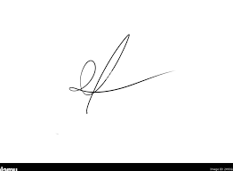
FRCS© NCMP
Clinical Assistant Professor, UBC
Department of Obstetrics and Gynecology SMH

